**VIT Modern Application Development (Java SpringBoot) 2023**

NAME: Alan Shaji

REG. NO.: 20BRS1024

**ASSIGNMENT 2**

1. Create, update, delete commands in MySQL.

create database assignment;

create table assignment.student

(sno int primary key,

studentId int,

studentName varchar(20));

drop table assignment.student;

insert into assignment.student values(1,1001,'Alan');

insert into assignment.student values(2,1003,'Rohith');

insert into assignment.student values(3,1010,'Varun');

update assignment.student set studentName='Ryan' where sno=3;

OUTPUT:

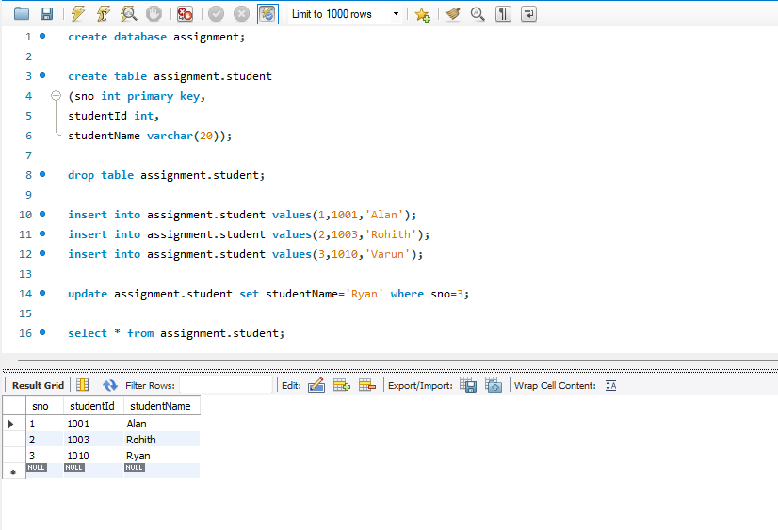

1. Create tables and perform joins in MySQL.

create table assignment.department

(sno int NOT NULL,

departmentId int NOT NULL,

departmentName varchar(45) NOT NULL,

primary key (`departmentId`),

unique key departmentId_UNIQUE (`departmentId`));

create table assignment.faculty

(sno int,

departmentId int,

facultyId int,

facultyName varchar(2),

primary key(sno),

foreign key(departmentid) references department(departmentid));

insert into assignment.department values(1,1,'CSE');

insert into assignment.department values(1,2,'ECE');

insert into assignment.faculty values(1,1,1,'AB');

insert into assignment.faculty values(2,1,2,'XY');

select * from assignment.department;

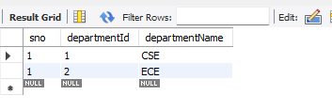

select * from assignment.faculty;

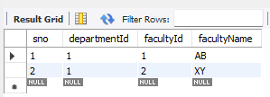

select * from test1.department left join test1.faculty on department.departmentId=faculty.departmentId;

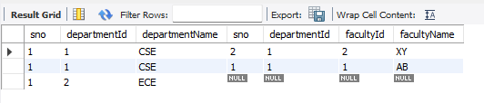

select * from test1.department right join test1.faculty on department.departmentId=faculty.departmentId;

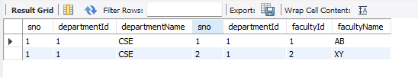

select * from test1.department full join test1.faculty;

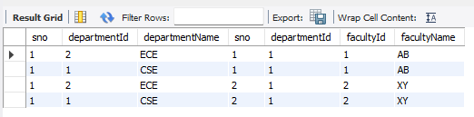

1. Create, update, delete commands in MongoDB.

db.createCollection(‘assignment’);

show collections;

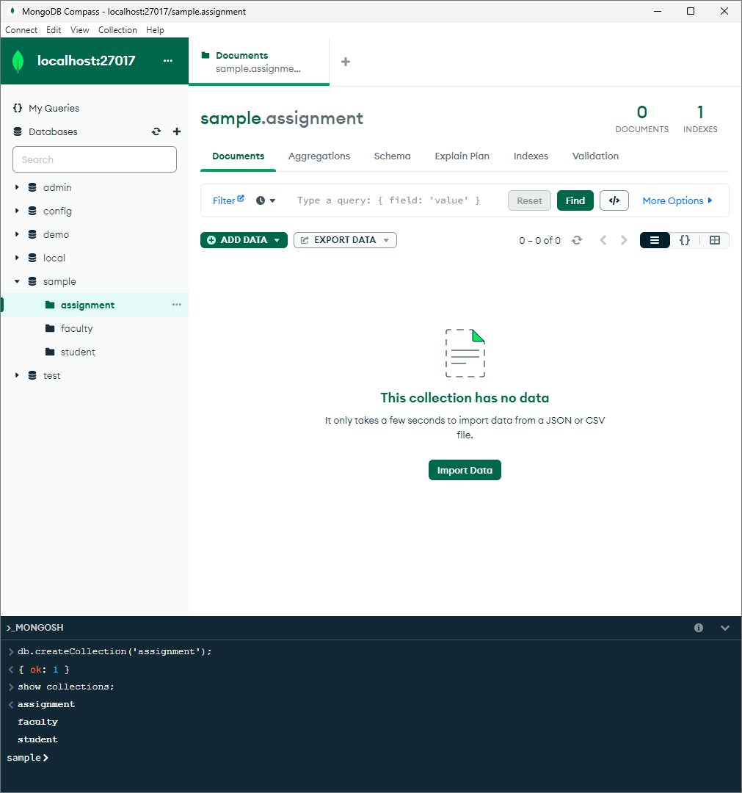

db.assignment.insertOne({studentName:'abc',age:20,address:'blg'});

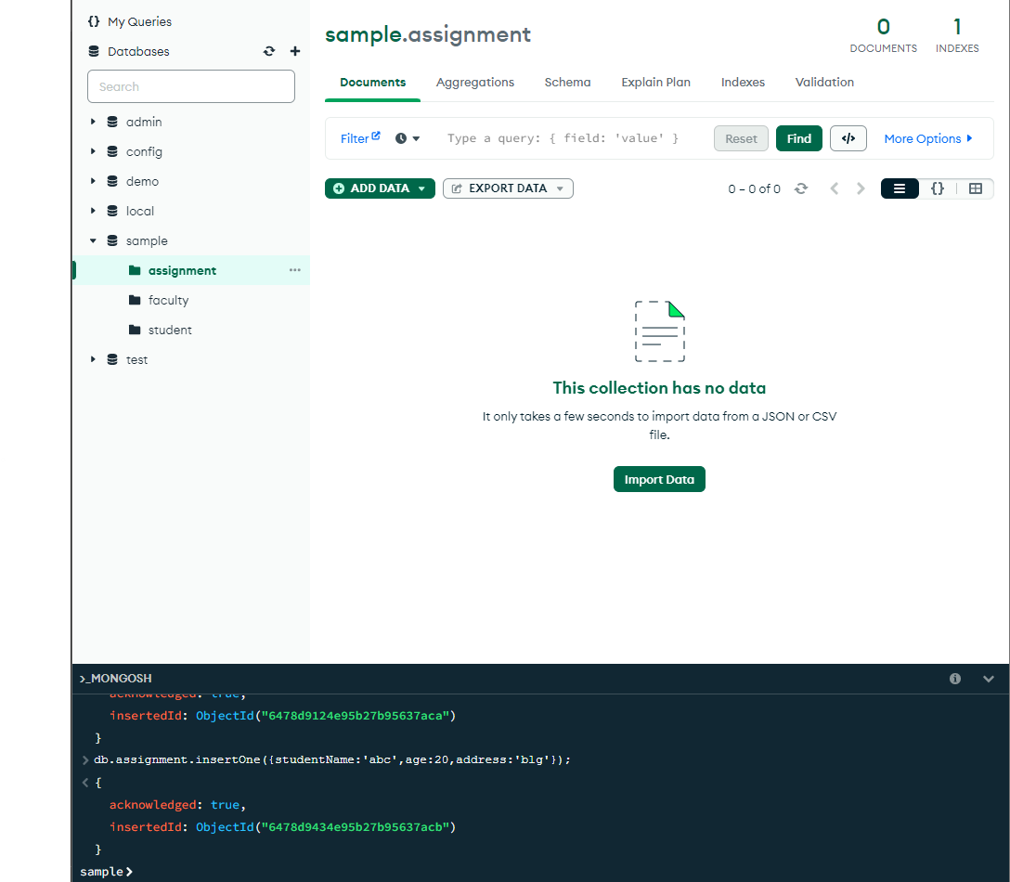

db.assignment.updateOne({studentName:'abc'},{$set:{address:'chn'}})

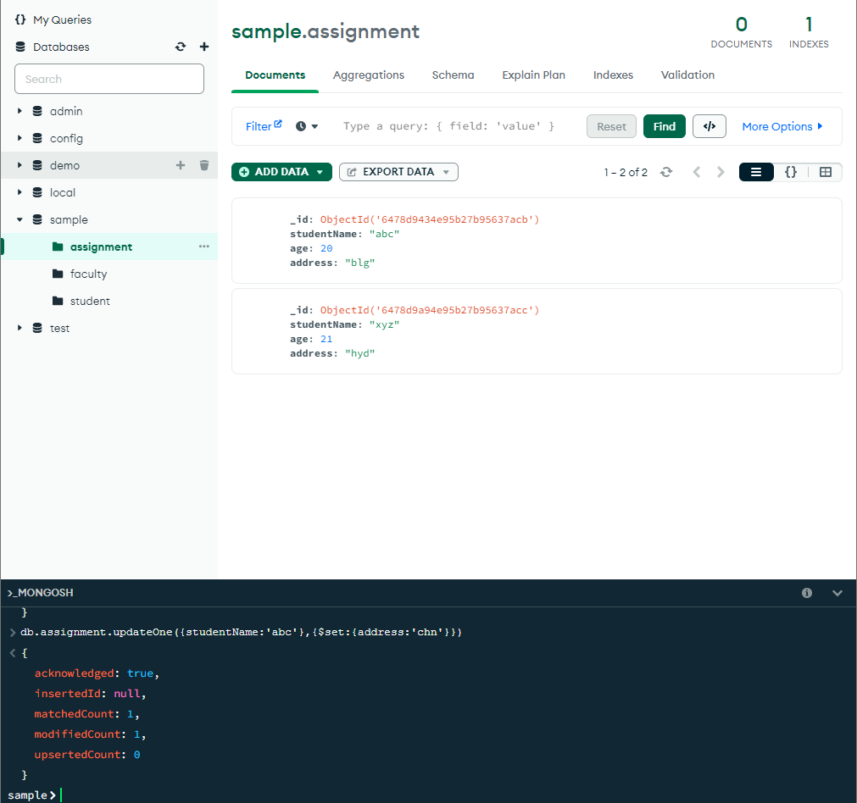

db.assignment.deleteOne({studentName:'xyz'})

